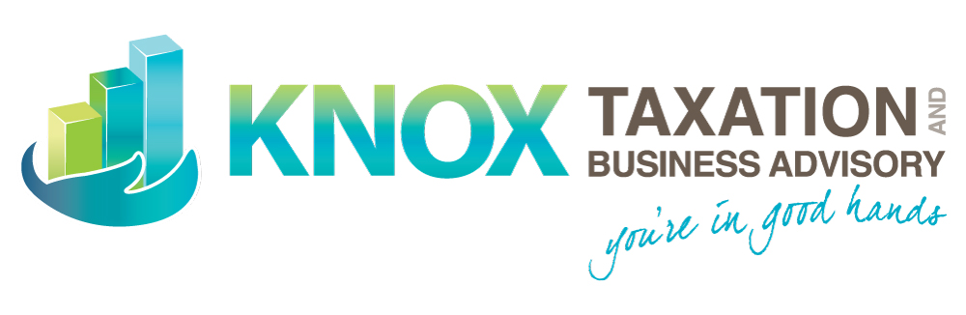

2023 FRINGE BENEFITS TAX
(FBT) QUESTIONNAIRE

BUSINESS NAME:

At any time from 1 April 2022 to 31 March 2023, did you:

☐ make vehicles owned or leased by the business available to employees/associates for private use?
☐ provide car parking benefits to employees?
☐ provide loans at reduced interest rates to employees/associates?
☐ forgive or release any debts owed by employees/associates?
☐ pay for, or reimburse, any private expenses incurred by employees/associates?
☐ provide a house or unit of accommodation to employees/associates?
☐ provide accommodation or reimburse rent and other living expenses to an employee living and working in a remote area
☐ provide employees with living-away-from-home (LAFH) allowances or LAFH benefits?
☐ provide entertainment by way of food, drink or recreation to employees (including any Christmas party)?
☐ provide any employees with a salary package (salary sacrifice) arrangement?
☐ provide any employees/associates with goods at a lower price than they are normally sold to the public?
☐ financially assist an employee in relation to a relocation, whether permanent or temporary

* An “associate” is a relative of an employee, such as a spouse or a child.

If you ticked one or more of these questions then we will need to calculate any potential FBT liability, or to minimise it.

Please take the time to complete this checklist as it is a very important part of the FBT process. It helps you:

- Identify and provide the information we need to prepare your Fringe Benefits Tax Return
- Minimise the queries from us during the preparation of your Fringe Benefits Tax Return
- Ensure we can complete your Fringe Benefits Tax Return by the due date of 27 June 2023

